“We are currently preparing students for jobs that don’t yet exist, using technologies that haven’t been invented, in order to solve problems we don’t even know are problems yet.”

- Former U.S. Secretary of Education Richard Riley
2019 St. John Catholic School Invention Convention

I am very pleased to announce that once again St. John Catholic School will be hosting our Annual Invention Convention on May 23rd. The Next Generation Science Standards that are on target to be implemented in the coming years contain engineering components that will be adopted by all grade levels. By integrating these components now, our students will be at the forefront of our evolving educational standards and years ahead of their counterparts at other educational institutions.

All students will be participating in The Invention Convention in one way or another. These projects, and the research leading up to them, combine hands-on, problem-based learning and relate directly to our current Common Core English/Language Arts Standards as well as the Next Generation Science Standards. This process will start with students identifying a problem and examining possible solutions. They will then conceptualize an invention that will solve this problem. Depending on grade level there will be different degrees of research and development done for each invention.

Once complete, students in grades 4-8 will be required display their inventions at our Invention Convention. Students will discuss, present, and even “Pitch” their inventions to teachers, families, and guests. Students will also be recommended for awards and given the opportunity to win some great prizes.

Classes will soon start discussing inventions and researching problems that their inventions will solve. Each grade has different timelines as to when each component will be due. I will be working closely with teachers to convey any information you may need. I look forward to working with all SJCS families to make this project and event both educational and fun. Please contact me if you have any questions or comments.

-Daniel Enos
denos@csdo.org

“I Can” Statements & S.T.E.M. Approach

Critical Thinking | Collaboration
Thinking about the problems in new ways  I can ask What if? And Why not?  I can solve problems  I can analyze and compare | Working together  I can work in a team.  I can be flexible.  I can be a follower or a leader
Communication | Creativity
Stating thoughts and ideas  I can discuss my ideas.  I can listen to others  I can evaluate what i think and hear | Using new approaches to get things done  I can brainstorm ideas  I can think of new things  I can consider other suggestions.

1. ASK | 3. PLAN | 5. IMPROVE
Find out more about the problem.  What is the problem?  What are possible solutions?  What have others done? | Think ahead about the steps.  Is the plan possible?  Where should I start?  What materials are needed? | Look at the model. Make it better.  Does it work?  What will make it better?  What can be done differently?
2. IMAGINE | 4. CREATE | 6. COMMUNICATE
Think big! Consider the possibilities.  What are the possibilities?  What else can be done?  What is the best solution? | Follow your plan. Make a model  Can a model be made?  Have I followed the plans?  Does it meet the goal? | Get feedback. Talk to others.  Are changes needed?  What do others think?  Is the problem solved?

Essay (4th - 8th Grade)

Format
- At least 5 paragraphs of good information, well written in your own words.
- Typed and double spaced.
- One-inch margins, 12pt font (Times New Roman font only)
- Cite references. (If you use exact quotes a Works Cited, in MLA format must be attached on separate sheet of paper.)

Essay

Introduction - Ask (1 Paragraph)
- State the problem you encountered.
- Why did you select this problem? (Explain how this problem negatively affects you or others)
- What are possible solutions?
- What have others done?
- Who would benefit from a resolution to this problem? (Explain why a resolution would be beneficial.)

Body - Imagine (1 Paragraph)
- What are the possibilities?
- How does your invention solve the problem?
- What else can be done? (How do you use it?)
- What is the best solution?

Body - Plan (1 Paragraph)
- Is the plan possible?
- Where should you start?
- How are you going to build your invention?
- What materials do you need to build your invention?

Body - Improve (1 Paragraph)
- What currently exists that solves, or attempts to solve your problem?
- What makes existing inventions insufficient?
- How is your invention better than everything that already exists?
- Is there a way your invention can be improved upon? (Could it be better if you knew more about electronics? Programing? Woodworking? etc.)

Conclusion (1 Paragraph)
- Does it solve the problem?
- A summary of key points that were made in the above paragraphs. Include relevant details and critical background information.

Project Board

Students, in order to present your invention to the school and community, you must organize your information on a tri-fold project board (similar to the Science Fair). Your project board presentation must include, but is not limited to, the following: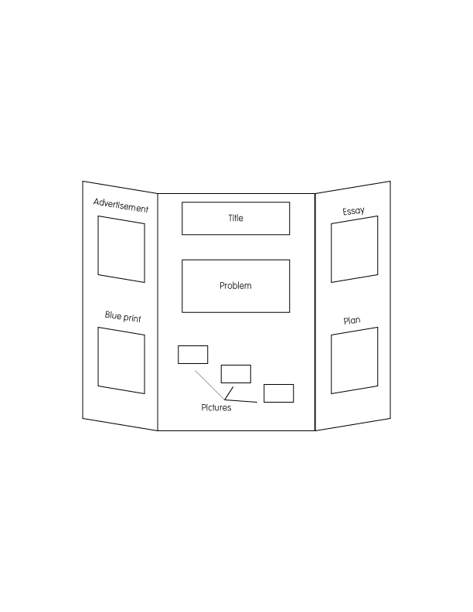

- An advertisement for your invention (please include any data that would help in promoting your product)
- A blueprint of your invention
- Name of your invention (Title)
- State your problem
- Pictures of you and your invention throughout the various stages of development
- Invention Convention Essay
- Plan - List of parts needed to build your invention and procedure used to create it

The winners of the Invention Convention will be decided based on the above items; however, grading rubrics will vary depending on the grade level. Below is a suggested timeline (to be completed at home and at school). Be sure to be neat and creative in creating your project board, GOOD LUCK!

April 17th, 2019 Draft 1 of Essay Complete
May 3rd, 2019 Final Draft of Essay Complete
May 10th, 2019 List of Parts Complete
May 10th, 2019 Procedure Complete
May 17th, 2019 Blue Print Complete (will be done in Art Class)
May 17th, 2019 Advertisement Complete (will be done in DMA/Coding)
*May 21st, 2019 Project Board Complete (*to be worked on at home)
*May 21st, 2019 Invention built and Complete (*to be worked on at home)
*Please note: items to be worked on at home should be started as soon as possible to be completed by the due date.

Please join us for the Invention Convention on May 23rd at 6:00pm in the gym!
Thank you!

